**Identify Active Long running Queries:**

Get the list of current long running queries, run either one of the following:

Sp_whoisactive or SP_Blitzwho

Get the list of blocked queries:

EXEC sp_WhoIsActive @find_block_leaders = 1,@sort_order = '[blocked_session_count] DESC'

**Identify Long running Queries history:**

View log running queries in last 2 hours (Enabling querystore is a prerequisite for this script)

SELECT TOP 50 rs.avg_duration/1000000 as [avg_duration_Sec], rs.max_duration/1000000 as maxDurationSec,qt.query_sql_text,q.query_id,p.plan_id,count_executions,  
object_name(q.object_id) as [objectname],rs.avg_logical_io_reads,  
rs.avg_physical_io_reads,rs.avg_tempdb_space_used/128 as [avg_tempdb_space_used_MB],

rs.avg_query_max_used_memory/128 as [avg_query_max_used_memory_MB],avg_cpu_time

FROM sys.query_store_query_text AS qt

JOIN sys.query_store_query AS q

ON qt.query_text_id = q.query_text_id

JOIN sys.query_store_plan AS p

ON q.query_id = p.query_id

JOIN sys.query_store_runtime_stats AS rs

ON p.plan_id = rs.plan_id

WHERE rs.last_execution_time > DATEADD(MINUTE, -120, GETUTCDATE())

ORDER BY rs.max_duration DESC;  
  
Get the average duration for an SP in specific timeframe:  
GetAvgdurationforSP 'DatabaseName','SPName',  
'FromTime-UTC','ToTime-UTC'

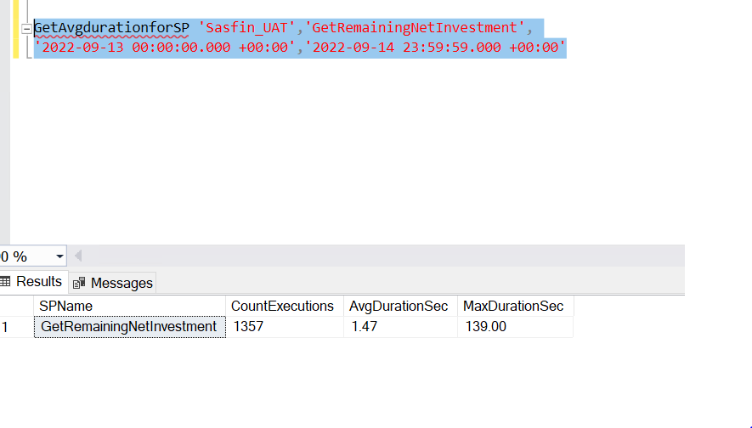

**Identify IOPS/Throughput Bottleneck (Only for SQL Managed Instance):**

Get IOPS/throughput for all the databases, run the below SP. (If any of the databases are above MaxIOPS or MaxthoughputLimitMBPS, then there’s a bottleneck with IOPS)

Getthroughputstats

**Identify Bottleneck from SQL Server waittypes:**

To get the SQLServer waittypes, please run  
  
Getdbperformance 'waits'

If any of the below waittypes with very high percentage is observed, it indicates the following:  
  
**RESOURCE_SEMAPHORE/RESOURCE_SEMAPHORE_QUERY_COMPILE:** There’s a bottleneck with CPU/Memory on SQL Server. Run sp_whoisactive to identify the long running query. Run Getdbperformance 'memoryqueries' to get queries using high memory.

**ASYNC_NETWORK_IO** : Bottleneck with Client/Application side. Check Application server CPU/Memory usage.  
 **LCK_M_U or LCK_M_IX or LCK_M_X:** There’s Locking/Blocking at SQLServer level. Run sp_whoisactive to identify root blocker.

**PageIOLatch_\***: SQL server is waiting on disk. Very high percentage of this waittype indicates disk IO pressure.  
  
**PageLatch_\***: Check for the database id related to this waittype. If the tempdb is under pressure, look for queries using tempdb/make sure tempdb is setup asper the best practices. Consider increasing the number of files.  
exec Gettempdbusage  
**Identify Bottleneck from Database server with Performance Counters:  
(Applicable only for Azure SQL VMs/Onpremise)**

Setup and run Windows Performance Counters for a fixed timeframe to monitor disk/cpu/memory usage on DB server/App server.

**Get list of Deadlocks in last 24 hrs:**

For Onprem/SQL VMs,  
  
OC_GetDeadlockinfo 24

For SQL MIs,

OC_GetDeadlockinfoAzure 24

**Get tuning recommendations in Azure SQL MI:**

To get the list of queries which were automatically pinned and get the list of queries which needs to be pinned, run below sp.

GetTuningRecommendations 'DatabaseName'